# **Lab x: Setting up LAMP stack using kubernetes**

## **In this lab, a LAMP (Linux, Apache, MySQL, and PHP) stack will be set up using Kubernetes.**

**Task 1: Creating a Secret**

1. Download the secrets file from git hub and apply the file to add the secret:

$ kubectl create -f secrets.yaml

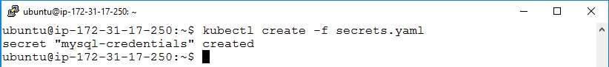

1. Verify if the secret has been added

$ kubectl get secrets

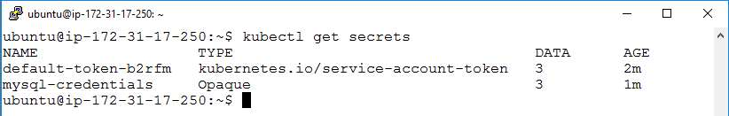

**Task 2: Setting up MySQL**

1. Download the **mysql.yaml** from git hub and apply the downloaded **mysql.yaml** using command:

$ kubectl create -f mysql.yaml

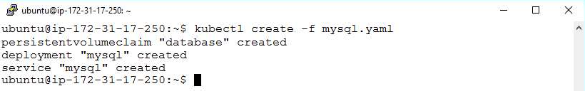

1. Verify the previous step by entering the following commands:

$ kubectl get pv

$ kubectl get deployments

$ kubectl get svc

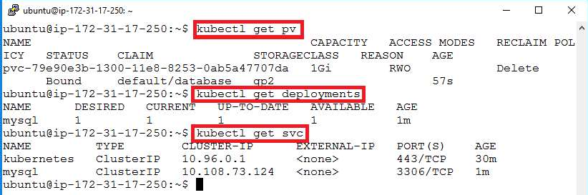

**Task 3: Setting up PHP**

1. Download the **php.yam**l from the git hub and apply the previously downloaded **php.yaml**

$ kubectl create -f php.yaml

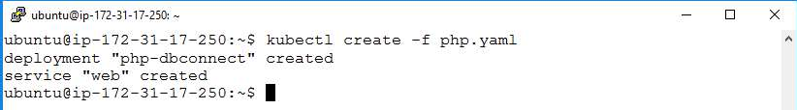

1. Verify the previous step by running the command below:

$ kubectl get deployments

$ kubectl get svc

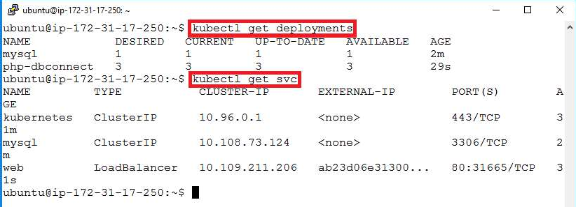

1. Verify the previous step by running the command below:

$ kubectl get deployments

$ kubectl get svc



1. Get the address to access the page with the below command. Then copy the **LoadBalancer Ingress** address

$ kubectl describe svc web

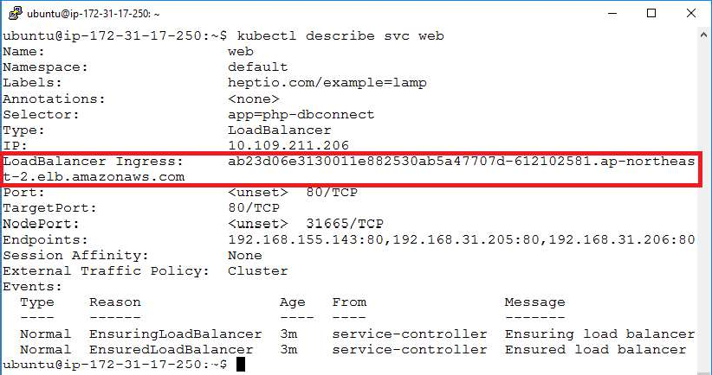

1. Paste the **LoadBalancer Ingress** address in a browser to access the PHP page

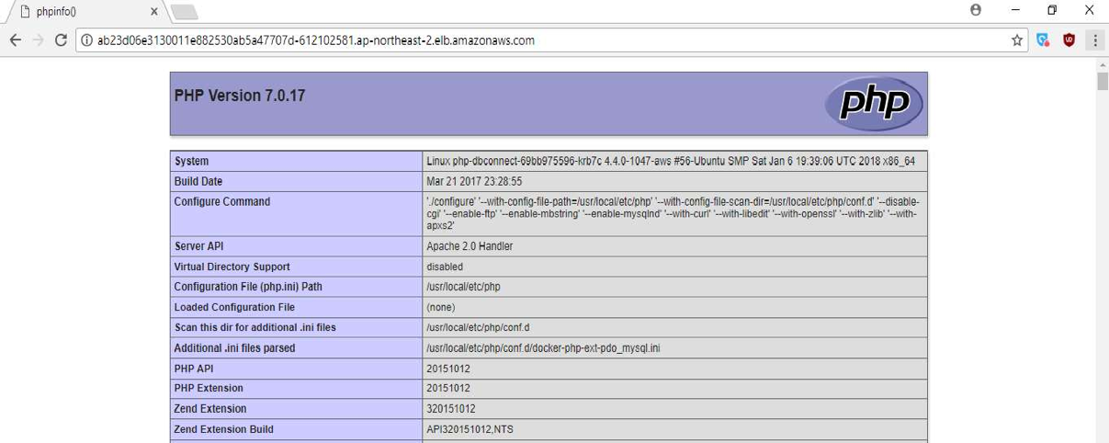

**Task 4: Cleanup**

1. Run the commands as shown below to delete previously created resources

$ kubectl delete secret mysql-credentials

$ kubectl delete -f php.yaml

$ kubectl delete -f mysql.yaml

